**NANDHA ENGINEERING COLLEGE**

(An Autonomous Institution, Affiliated to Anna University, Chennai)

# ERODE–638052



## 

## A Project Report

***Submitted by***

KABINE.R (23AI025)

*In partial fulfillment for the award of the degree*

*of*

# BACHELOR OF TECHNOLOGY

# IN

# ARTIFICIAL INTELLIGENCE AND DATA SCIENCE

**DEPARTMENT OF ARTIFICIAL INTELLIGENCE AND**

**DATA SCIENCE**

**What is Tableau?**

* Tableau is a powerful and easy-to-use data visualization tool that helps people understand data.  
* It allows users to create beautiful charts, dashboards, and reports without needing to write complex code.  
* With Tableau, we can turn raw data into clear, interactive visual stories to find trends, patterns, and insights.  
* It is widely used in businesses, research, and education to make better decisions by seeing data visually.

**Project : Eletric Vehicle Data Intelligence**

In this project, we are using Tableau to study and understand electric vehicle (EV) data.

The main aim is to turn raw EV data into beautiful and interactive dashboards that show:

*Total number of electric vehicles.

*Average electric range of Electric Vechicle

*Distribution of BEV (Battery Electric Vehicles) and PHEV (Plug-in Hybrid Electric Vehicles).

*Total vehicles by model year.

*Total vehicles by state.

*Top EV manufacturers and models.

*CAFV (Clean Alternative Fuel Vehicle) eligibility status.

**Steps in the Project:**

1. Connect Tableau to the EV Dataset (Excel or CSV file).

2. Clean and prepare the data (fix missing or incorrect values if needed).

3. Create visualizations like bar charts, pie charts, line graphs, and maps.

4. Build dashboards by combining different charts together.

5. Analyze the dashboards to find trends, patterns, and useful insights.

**Importance of This Project:**

## 1.Helps understand the growth and adoption of electric vehicles over time.

## 2.Identifies top-performing EV brands and models.

## 3.Shows regional distribution of electric vehicle ownership.

## 4.Supports better planning for EV production, marketing, and infrastructure.

## Total Vehical by Model Year:

## C:\Users\SIVAKABINE.R\Pictures\Screenshots\Screenshot 2025-04-27 040055.pngScreenshot 2025-04-27 040055

## 1. What This Chart Shows:

## This chart shows the total number of electric vehicles by model year from 2011 to 2023.

## It highlights how EV production and registrations have changed over the years, with major peak around 2022.

## **2. How We Built It:**

## Step 1: Connected the EV dataset in Tableau.

## Step 2: Selected fields: Model Year (X-axis) and Total Vehicles (Y-axis).

## Step 3: Used a line graph with area shading to visualize the trend clearly.

## Step 4: Added labels to show the exact number of vehicles for each year.

## **3. Purpose of This Chart:**

## To understand the growth trend of electric vehicle production and adoption year by year.

## To identify key years where EV production increased significantly or decreased.

## To support forecasting and planning for future EV development.

## Outcome:

## EV production has grown steadily, with sharp increases after 2017, peaking in 2022.

## There was a small dip in 2019 and a big drop in 2023 (probably because 2023 data might be incomplete).

## 2022 was the strongest year for electric vehicles with 26.5K units.

## Total Vehicle by State:

## C:\Users\SIVAKABINE.R\Pictures\Screenshots\Screenshot 2025-04-27 042016.pngScreenshot 2025-04-27 042016

## **1. What this chart shows**:

## - Shows total number of vehicles in each U.S. state.

## - States are colored (darker color = more vehicles).

## - Displays exact vehicle numbers on the map.

## **2. How we built it:**

## - Collected vehicle data for each state.

## - Opened Microsoft Word (or Excel/PowerPoint).

## - Inserted a Map Chart (Insert → Chart → Maps).

## - Entered State Names and Vehicle Numbers.

## - Added labels to show numbers on states.

## - Adjusted colors to highlight differences.

## **3. Purpose of this chart:**

## - To compare vehicle totals between states easily.

## - Quickly spot which states have more or fewer vehicles.

## - Help in decision making, reporting, or presentations.

## **4. Outcome:**

## - Created a visual map showing vehicle distribution.

## - Washington state is clearly shown with the highest number.

## - Easy to understand and analyze at a glance.

## Top 10 Total Vehicals by Make:

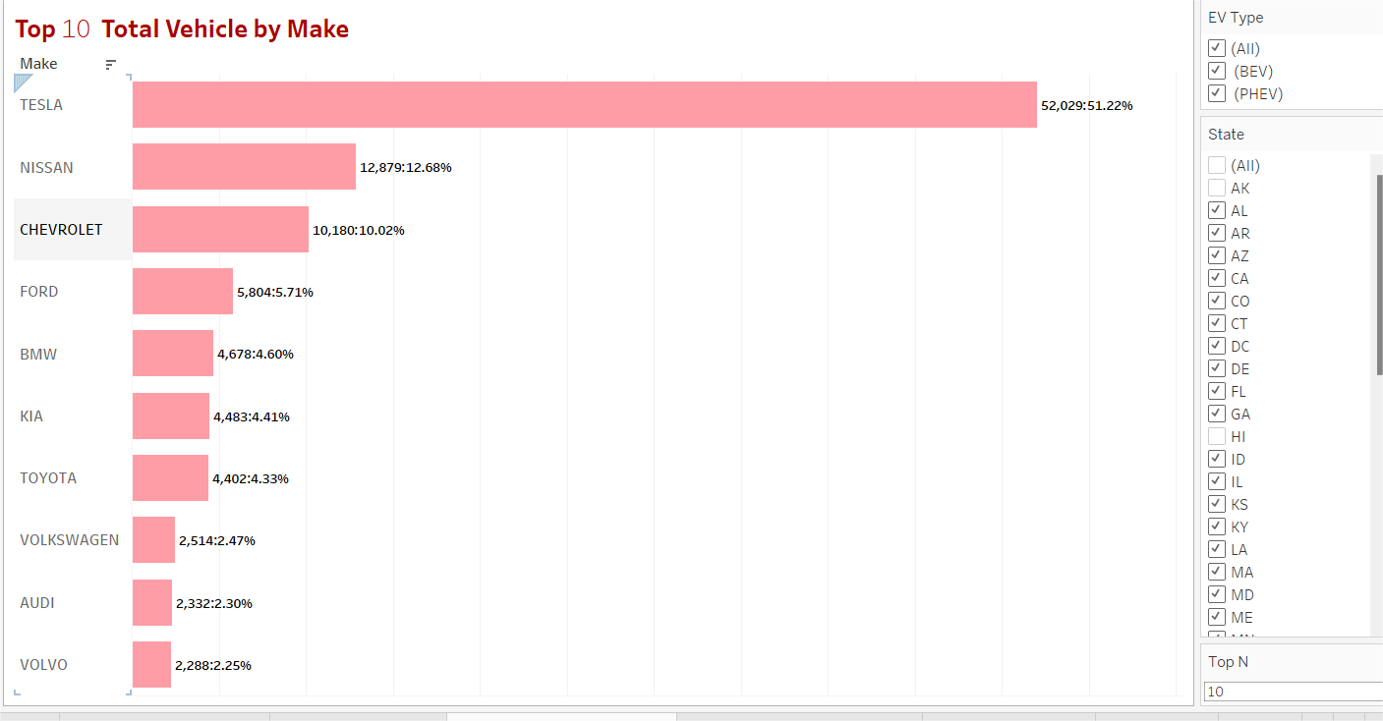

**1. What this chart shows:**

- It shows the top 10 car brands based on total number of vehicles.

- Ford has the highest number of vehicles among all brands.

- Percentages show each brand’s share out of total vehicles.

**2. How we built it:**

- Collected data: Vehicle count for each car brand.

- Opened Microsoft Word or PowerPoint.

- Inserted a Bar Chart (Insert → Chart → Bar).

- Added brand names on the Y-axis and vehicle counts on the X-axis.

- Displayed numbers and percentages on bars.

**3. Purpose of this chart:**

- To easily compare top car brands by the number of vehicles.

- To highlight which brand is the market leader.

- Helps in business analysis, market research, or strategy planning.

**4. Outcome:**

- A clear visual ranking of top vehicle brands.

- Ford is shown as the dominant brand with 51.22% share.

- Easy for the audience to analyze brand performance at a glance.

**Total Vehicals by CAFV Eligibility**

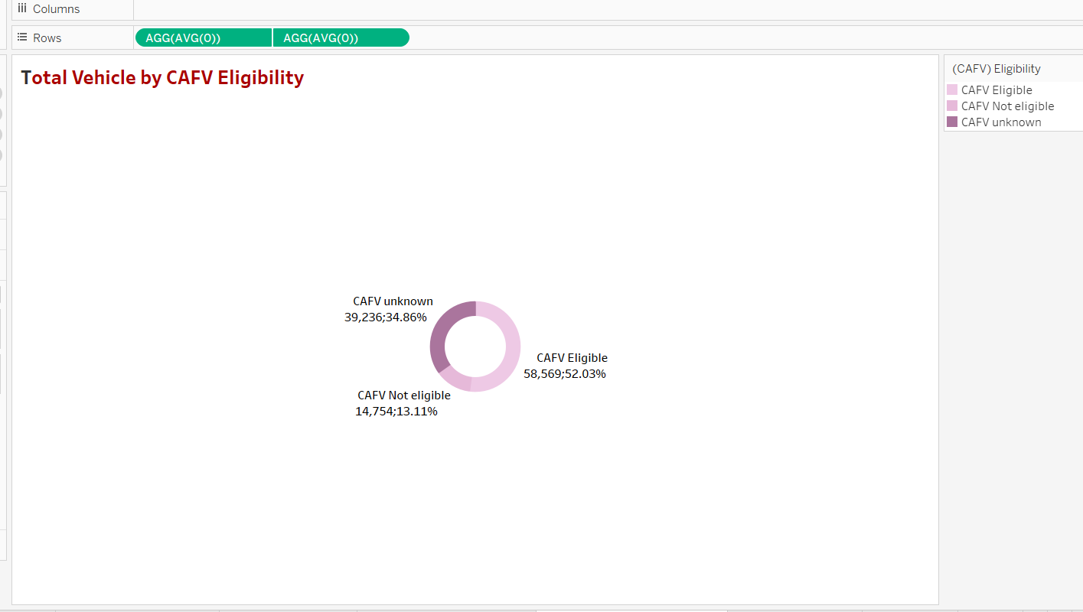

**1. What this chart shows:**

- It shows the distribution of total vehicles based on CAFV eligibility status.

- 52.03% of vehicles are CAFV Eligible, 13.11% are Not Eligible, and 34.86% are Unknown.

- Helps in understanding how many vehicles are eligible for clean alternative fuel programs.

**2. How we built it:**

- Collected data: Vehicle counts by CAFV Eligibility status.

- Opened a tool like Excel, Power BI, or Tableau.

- Created a Donut Chart (Insert → Chart → Pie → Donut).

- Entered three categories: Eligible, Not Eligible, Unknown.

- Added labels to show counts and percentages.

**3. Purpose of this chart:**

- To analyze how many vehicles are eligible for clean energy programs.

- Helps in reporting for government policies, environmental goals, or business strategies.

- Easy to compare eligible vs non-eligible vehicles at a glance.

**4. Outcome:**

- A simple, visual summary of vehicle eligibility.

- Shows that more than half the vehicles are CAFV eligible.

- Useful for quick decisions related to clean vehicle programs or incentives.

**Top Vehicals by Model:**

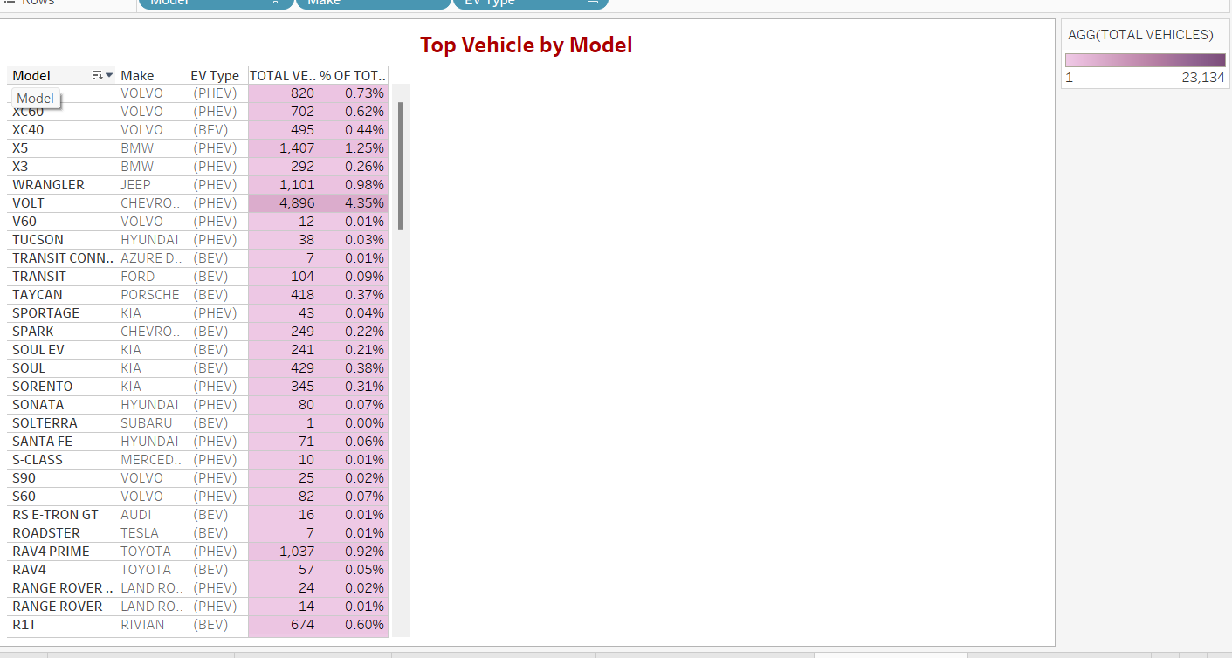

**1. What this chart shows:**

- Shows different vehicle models and their total number of vehicles.

- Displays the vehicle brand (make), EV type, and percentage share of total vehicles.

- Helps to identify top models in terms of volume.

**2. How we built it:**

- Collected vehicle model data (model name, make, EV type, total vehicles).

- Used Excel, Tableau, or similar tool.

- Created a grid/table chart listing model-wise details.

- Added total count and percentage columns.

**3. Purpose of this chart:**

- To rank and compare different vehicle models based on total numbers.

- To check which models and brands are most popular.

- Useful for market analysis, inventory planning, or sales strategy.

**4. Outcome:**

- A clear list of top vehicle models based on total vehicle count.

- Quickly shows the most popular models and types of EVs.

- Helps in making data-driven decisions for production, marketing, or selling focus.

**ELECTRIC VEHICLE DATA INTELLIGENCE:**

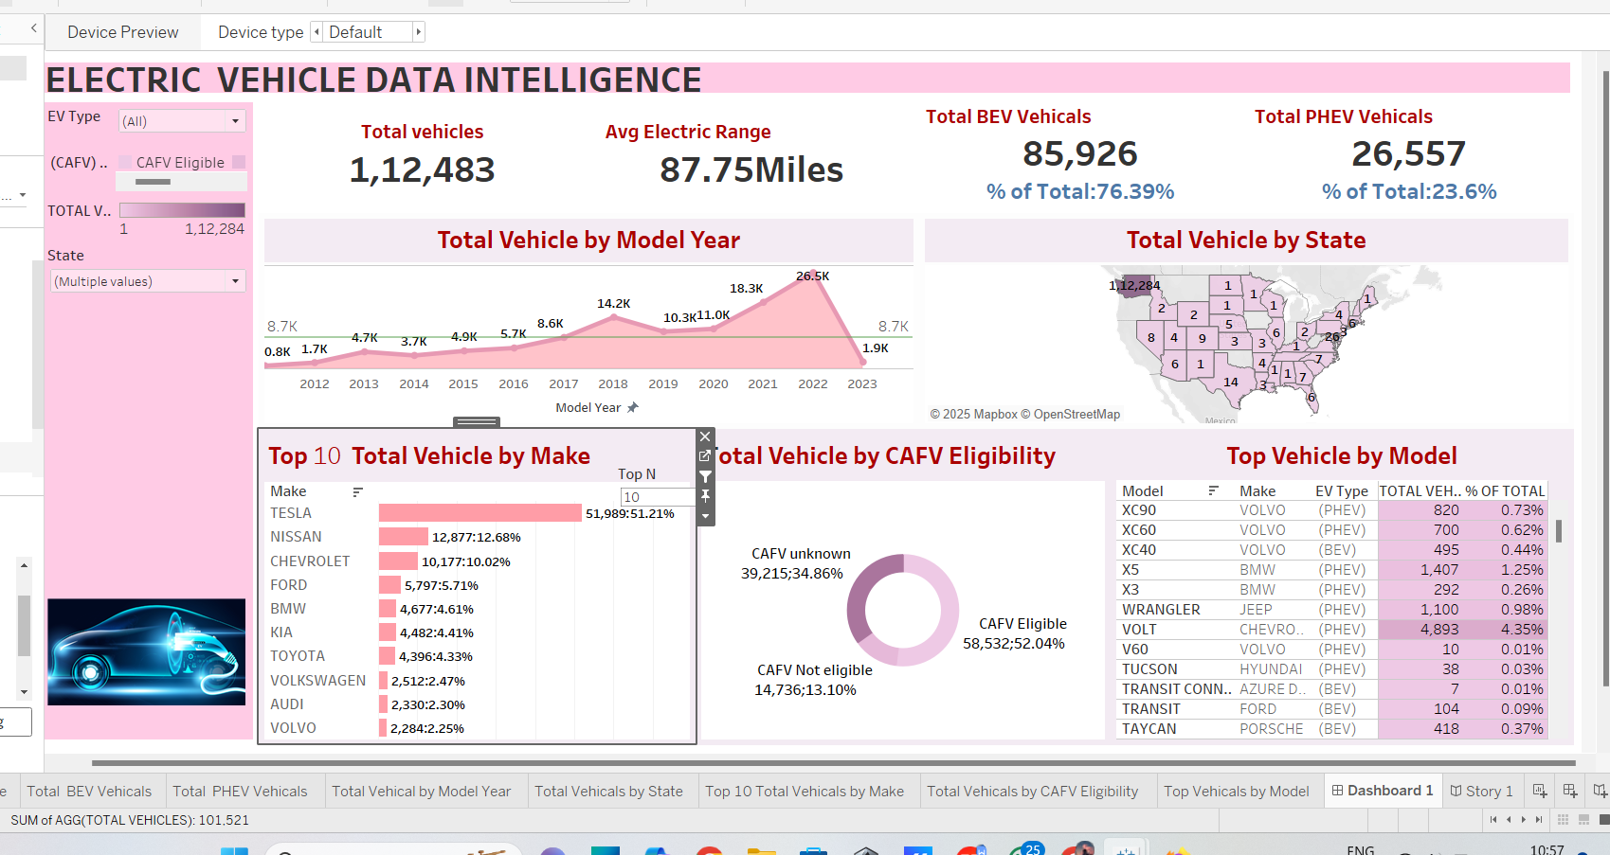

**Project Overview:**

**1. Objective:**

* To analyze and visualize electric vehicle (EV) sales data by state, make, model, EV type, and eligibility.
* To identify trends and support decision-making for the EV market.

**2. Data Source:**

* Raw sales data including EV types (BEV, PHEV), CAFV eligibility, vehicle counts, average electric range, and geographical distribution.

**3. Tools Used:**

* Tableau for dashboard creation and data visualization.
* Microsoft Word for project reporting and documentation.

**4.. Key Metrics Visualized**:

* Total Vehicles: 112,559
* Average Electric Range: 87.75 miles
* Total BEV Vehicles: 85,976 (76.38%)
* Total PHEV Vehicles: 26,583 (23.62%)

**5. Dashboard Components:**

* Line Chart for vehicle counts over years.
* State-wise Vehicle Distribution
* Top 10 Vehicle Makes
* Top Vehicle Models- CAFV Eligibility Status

**6. Dashboard Components:**

* Line Chart for vehicle counts over years.
* Map Chart for total vehicles by state.
* Bar Chart for top vehicle makes.
* Donut Chart for CAFV eligibility.
* Table View for top vehicle models.

**7. Purpose:**

* To present a full overview of electric vehicle sales performance.
* To compare different brands, models, and regions.
* To help businesses and policymakers understand EV market opportunities.

**8. Outcome:**

* Created a professional and interactive Tableau dashboard.
* Gave clear insights into EV adoption trends.
* Supports better planning, marketing strategies, and EV promotion policies.

**Conclusion :**

**The Electric Vehicle Data Intelligence** dashboard successfully provides a **comprehensive and interactive view of the electric vehicle market.**

**Using Tableau**, complex data was transformed into **simple, powerful visualizations** that clearly highlight trends in vehicle types, brand popularity, state-wise distribution, and CAFV eligibility.

The analysis reveals a strong dominance of **Battery Electric Vehicles** (BEVs), with brands like **Ford and Tesla** leading the market.

Additionally, the insights on **CAFV eligibility and average electric range** offer valuable information for policymakers, manufacturers, and environmental initiatives.

This project not only improves **data-driven decision making**, but also supports the broader goal of accelerating **electric vehicle adoption** and building a **greener, sustainable future.**

By presenting key insights in a visually intuitive manner, the dashboard stands as a **powerful tool** for understanding and growing the EV ecosystem.

.